Course Project

Christopher F. Iwen

DeVry University

Author Note

This paper was prepared for COMP-230

taught by Professor S. Kuchel

I created a VB script to connect to a specific printer and shared folder on my network, both located on a computer named Alice. When the script is run it pops up a message box greeting the user by login name (in this case Alienware) and welcoming the user to the computer (in this case named Valhalla). The first message box will ask the user if they want to add the network drive and give them 2 options. The options are yes or no. if the user chooses yes it will load the next work drive as the Z:\ drive. If the user chooses no it will skip to the next part of the script. The next part pops up a message box again asking the user if they’d like to connect to the network printer. If the user chooses yes then the script loads the shared printer and sets it to default so that it will be ready for use without any other user interactions. If the user chooses no then it will skip to the next part. Then next part only runs if the user chooses to map the network drive. If they did map the network drive the script checks to see if the Z:\ drive is there. If it is it confirms it for the user, and if it didn’t then it tells the user they should run the script again. After that the script closes out and stops running.

'VBScript: FinalProject.vbs

'written by: Christopher Iwen

'Date: 01/14/16

'Class: Comp230

'Professor: Stanley Kuchel

'=================================================

'Used throughout the script (pg. 179)

'====================================

Dim strDomain , strUser , oNetwork , vResult , vaResult

Set oNetwork = CreateObject("WScript.Network")

strDomain = oNetwork.UserDomain

strUser = oNetwork.UserName

'Questions and user input (pg. 103-105, 179)

'pulls computer name and user name for the MsgBox

'askes user if they'd like to access the network drive

'=====================================================

vResult = MsgBox ("Welcome to " & strDomain & ", "& strUser &"!" &_

vbCr & "Would you like to access the Network Drive?", _

36, "Network Share Script")

If vResult = 6 Then

'if user chooses yes then

'Map Network Drive (pg. 175)

'and use the given user name and password

'if user chooses no move on

'to the next question

'========================================

oNetwork.MapNetworkDrive "Z:" , "\\Alice\Share", _

False, "mygu", "1derland"

end if

'Questions and user for input (pg. 103-105, 179)

'ask user if they want to access the network printer

'===================================================

vaResult = MsgBox ("Would you like to access the Network Printer?", _

36, "Network Share Script")

If vaResult = 6 Then

'If the user chooses yes

'Add Network Printer (pg. 177)

'located at \\Alice\Printer

'If the user chooses no skip

'=============================

oNetwork.AddWindowsPrinterConnection "\\Alice\Printer"

'Set Network Printer as Defualt (pg. 178)

'========================================

oNetwork.SetDefaultPrinter( _

"\\Alice\Printer")

end if

'If you chose to load the network drive

'Check to see if the network drive

'was loaded as drive Z:\ (pg. 197-198)

'and inform the user. otherwise tell the user

'they didn;t shoe to load the Network drive.

'=============================================

Dim oFSO , oFolder

set oFSO = WScript.CreateObject("Scripting.FileSystemObject")

If vResult = 6 Then

If oFSO.FolderExists("Z:\") Then

MsgBox ("The network drive has been mapped and loaded as the Z:\ drive")

Else

MsgBox ("The network drive has not been mapped try again.")

End If

Else

MsgBox ("you did not have the Network drive load.")

end if

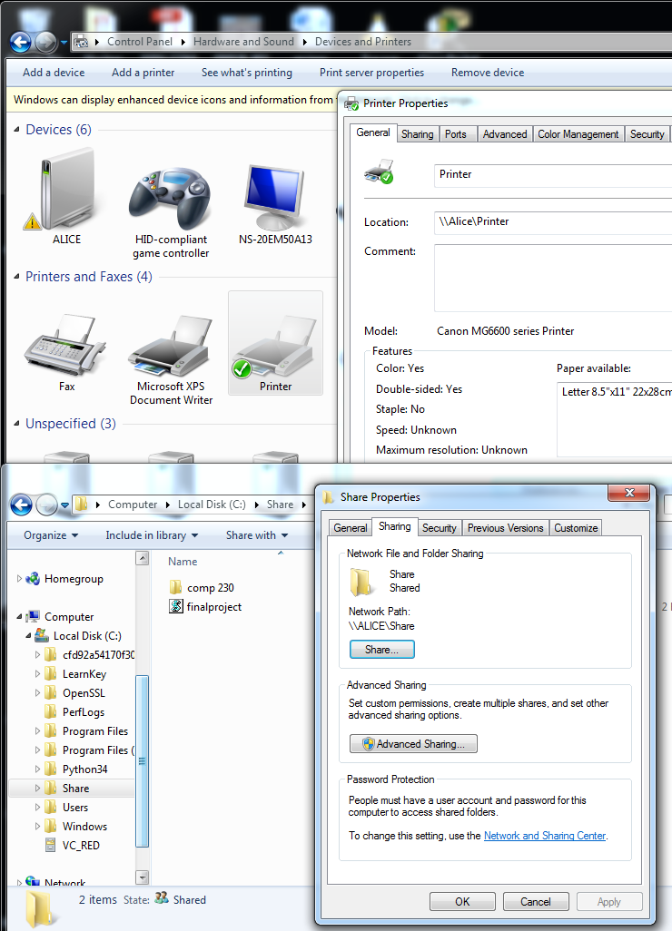

This first screen shot is to show where the printer and shared folder are located and named. As you can see the printer is named Printer and located at \\Alice\Printer which fits the VB script code. From the screen shot you can also see that the network share folder is located at \\Alice\Share. All other screen shots will come from the computer running the script to connect to these shared devices.

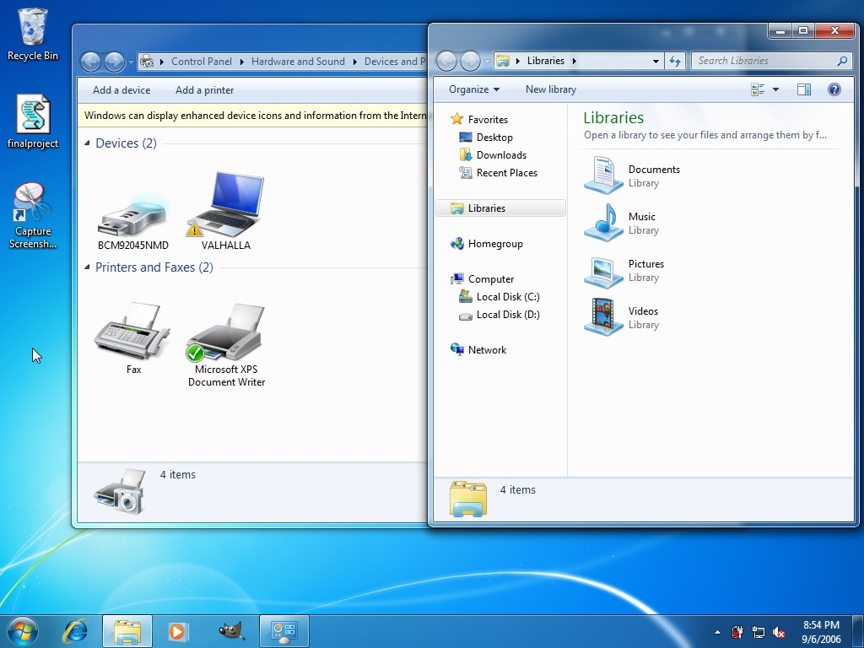

The second screen shot is on a computer named Valhalla with the user name Alienware and shows that it doesn’t have a printer or network drive loaded as of yet. You can also see the script on the left side of the screenshot named finalproject.

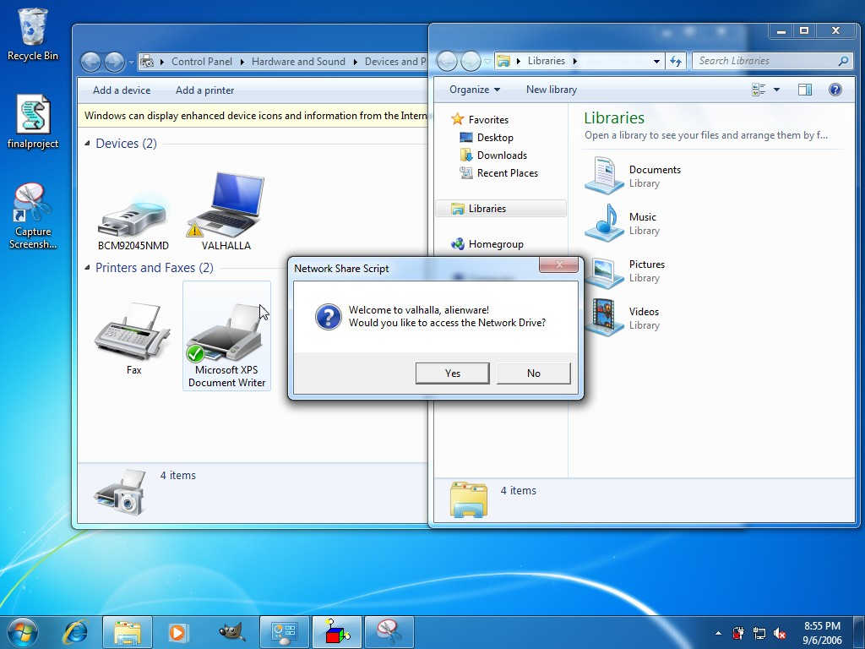

The third screenshot is showing the first message box that appears when the script is run by double clicking it. You will notice that it says Welcome to Valhalla (the computer name), alienware (the user name).

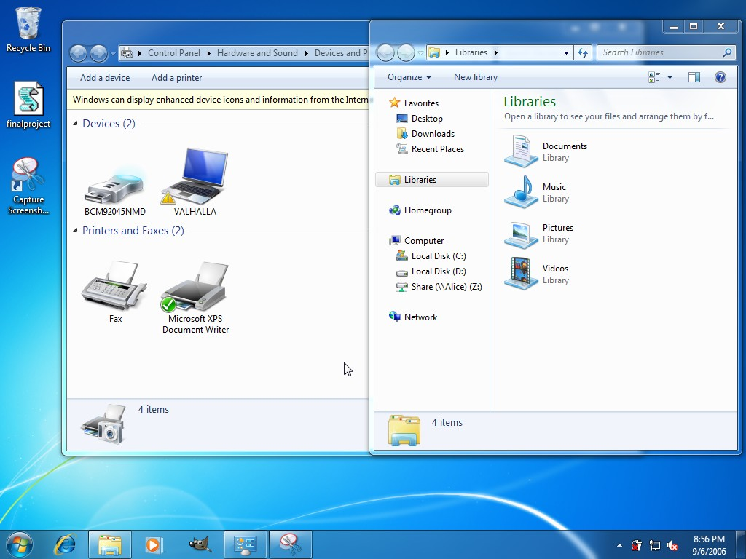

The fourth screen shot shows that the network drive known as share on the computer Alice has been loaded and is accessible. This is because I chose the yes button. Choosing the no button would of skipped to the next prompt without loading the network drive or saying anything.

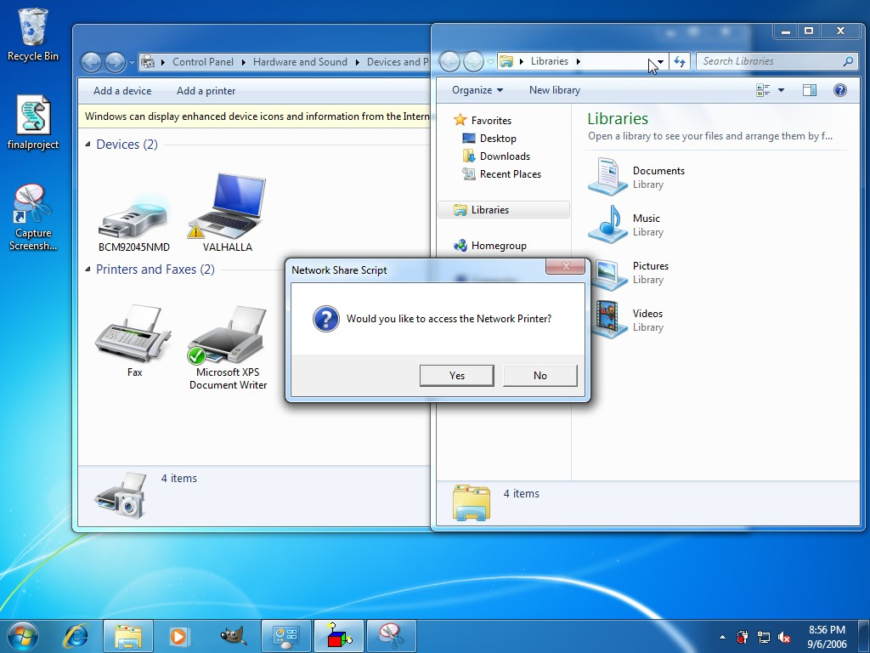

The next screenshot is the second prompt asking the user if they would like to map the network printer. If the user chooses no nothing will be loaded and the script will continue to the last if then statement. If the user chooses yes then the network printer is loaded and set as the default printer.

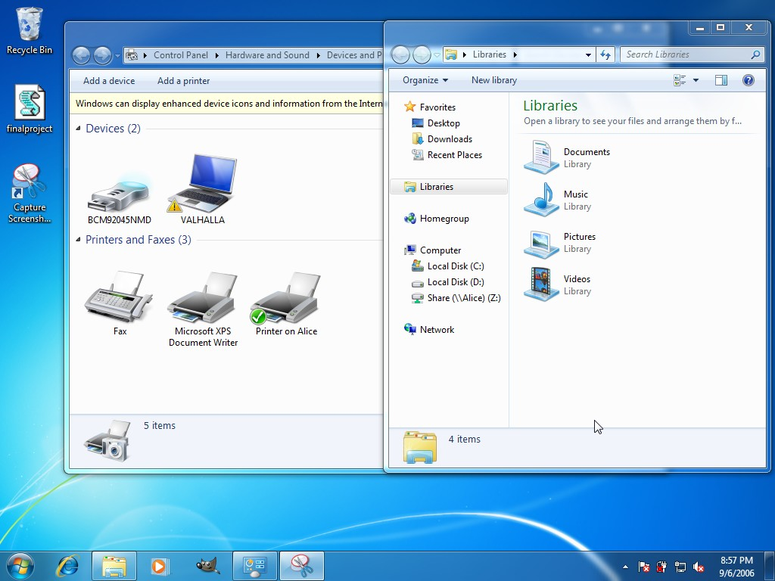

This next screenshot shows the network printer loaded and showing as located on the computer known as Alice.

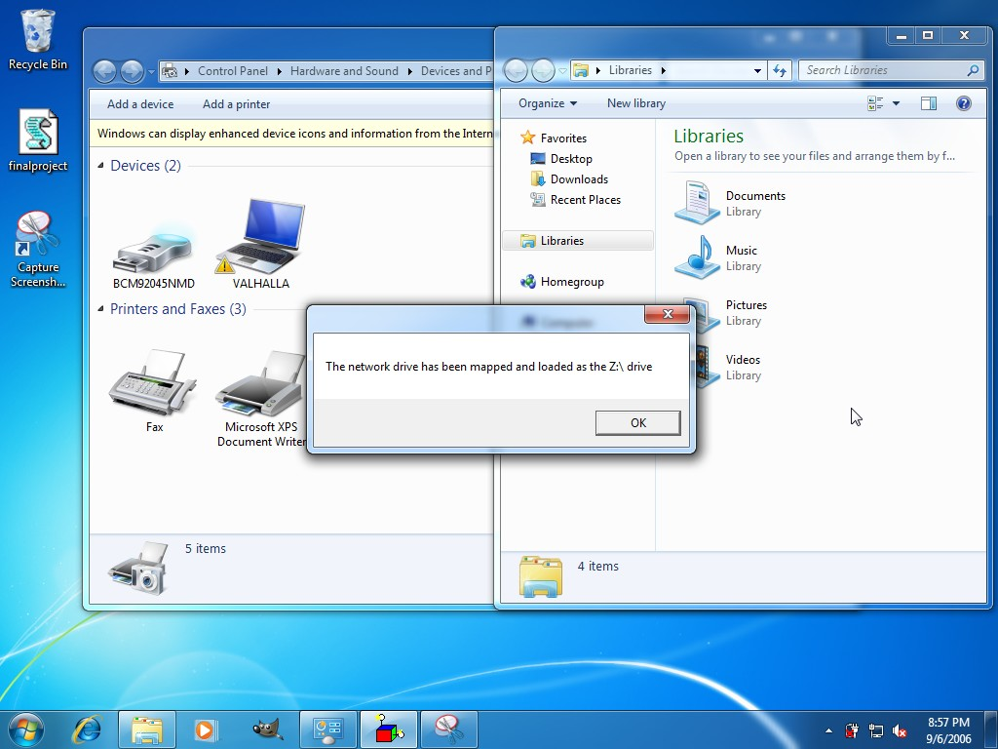

This final screenshot is a part of the last if then statement which checks to see if the network drive was in fact loaded, but only runs if the user chose yes on the first prompt asking if the network drive should be loaded. This completes the script and only gives the user a choice to click OK and close out the prompt, thus ending the script.

References

Jones, D. (2007). VBScript, WMI, and ADSI: Using VBScript, WMI, and ADSI to automate Windows administration. Indianapolis, IN: Sams.